Pink Ribbon Toolkit
Sell paper ribbons | Fight breast cancer

2025 W. Oklahoma Avenue, Suite 116 | Milwaukee, WI 53215
414.389.4888 | info@komenwisconsin.org

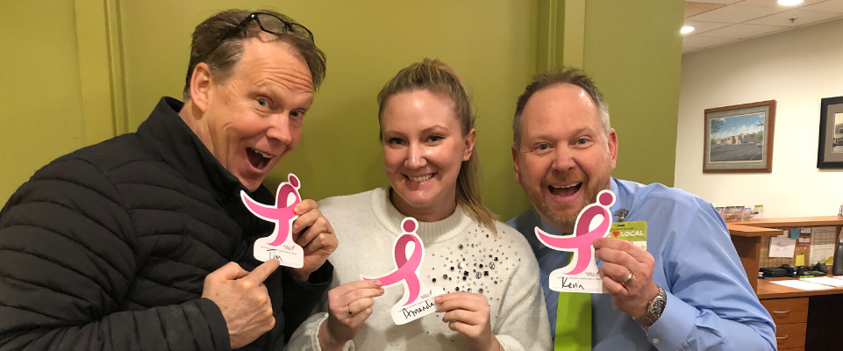

Selling paper donation ribbons is an easy way to fundraise within your community or business and join the fight against breast cancer! Because of people selling paper ribbons throughout the community, Susan G. Komen Wisconsin is able to help local neighbors in need.

How it works
As people make donations to Susan G. Komen Wisconsin, they can write their name on the paper ribbon and hang it on a wall, or other space, to collectively show the impact your organization/group has made.

Setting up paper ribbon sale fundraiser is easy!
- Read the Third Party Guidelines to answer your questions and give you some background information on hosting an event to benefit Komen Wisconsin.

- Register your paper ribbon sale fundraiser by emailing info@komenwisconsin.org.

- Once registered, you will be contacted by Komen Wisconsin to receive your paper ribbons and see how we can help you reach your fundraising goal.

- Utilize the toolkit materials to start planning!

How Komen Wisconsin Can Help
Paper ribbon fundraisers will be able to utilize Komen Wisconsin resources including:
- Permission to use the Susan G. Komen Wisconsin mark and logo
- Access to educational materials and information for your fundraiser

Be Prepared
- Set a fundraising goal for your ribbon sale.

- Determine the details:
  - Location, location, location! Find a spot to sell your ribbons that will provide you with a high traffic area. Make sure there is a lot of surface area to hang up ribbons as you sell them to show your impact.

  - Set the date! Choose a date or span of dates to host your ribbon sale.

- Be ready to collect donations. Donations can be collected:
  - Digitally using a bar code at the register
  - Via a donation jar at check-out (or wherever is convenient)
- make sure you have enough ribbons to meet your goal.

Get the Word Out
Make sure that your community knows when and where they can come out to support your ribbon sales event. Use email, social media and distribute flyers to share the information. Keep it short and sweet by including the most important details. Use the samples and examples below to get started!

Make It Fun
On the day(s) of your paper ribbon sale, let everyone know there’s an exciting event happening. Get into the spirit by decorating with pink items!

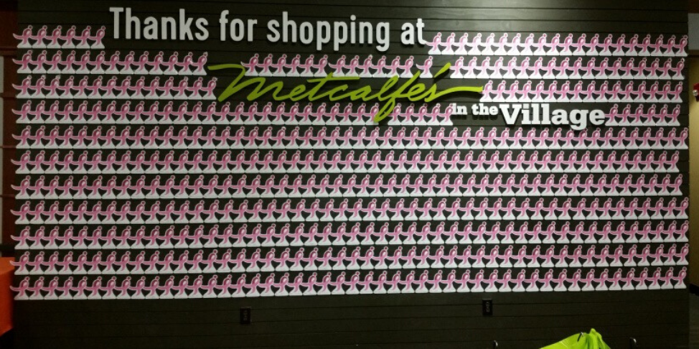

Sample Posts
We’re selling paper ribbons for @KomenWisconsin this (date)! Join us at (location) to purchase a ribbon — or two! — and help those affected by breast cancer!

Each week, 13 Wisconsin neighbors die from breast cancer. Help us reduce that statistic by stopping by (location) this (date) to purchase a paper ribbon! All sales benefit @KomenWisconsin.

Join us in saving lives from breast cancer. Stop by (location) this (date) to purchase a paper ribbon to benefit @KomenWisconsin.

We’re excited to sell paper ribbons this (date) to benefit @KomenWisconsin. Stop by (location) on (date) to help us raise awareness and funds for those battling breast cancer in Wisconsin.

Make sure to follow Komen Wisconsin and tag us in your posts!
@KomenWisconsin

Susan G. Komen was founded in 1982, as a promise between sisters to end breast cancer forever. Today, Susan G. Komen is the largest breast cancer nonprofit in the world fighting the most common cancer diagnosed in women.

We are more than just a color, and we do more than just raise awareness. Komen is the largest private funder of breast cancer research in the world and provides access to lifesaving breast health services to people across the country and the world through its Affiliate Network.

We are More Than Pink. We are a community of people, inspired by one sister's promise, to end breast cancer forever, and we will not stop until we have succeeded.

Our Vision
A world without breast cancer.

Our Mission
Save lives by meeting the most critical needs in our communities and investing in breakthrough research to prevent and cure breast cancer.

Our Goal
Reduce current number of breast cancer deaths by 50% in the U.S by 2026.

Headquartered in Milwaukee, with additional offices in Madison and Wausau, Susan G. Komen® Wisconsin is a statewide resource for individuals who need breast cancer screening, diagnostic and support services.

One-in-eight women will be diagnosed with breast cancer in her lifetime.

There are more than 4,730 Wisconsinites who are expected to be diagnosed with breast cancer this year alone.

We need your help. It is as simple as that.

Where Your Money Goes
Komen Wisconsin raises funds that enable women to detect and survive breast cancer. Funds raised support a variety of local breast cancer programs, as well as direct financial assistance for those in need of breast cancer screenings, diagnostic tests and treatment services.

Locally, in Wisconsin, we have invested more than $26.5 million right here at home and contributed more than $7 million to research. Despite these efforts, as many as 710 Wisconsin families still lose their loved ones to breast cancer this year.

With your help, we will continue to advocate, provide assistance for clinical trials and fund research to drive down the horrifying number of 710 moms, daughters, sisters and friends who are expected to die from breast cancer this year.

1. EXPENSE RATIO: As a responsible steward of public funds, the Komen Foundation believes that a reasonable percentage of the gross revenues from all fundraising activities should be directed to our mission. A third-party event, promotion, or benefit is required to keep expenses under 25% of gross revenue. Exceptions may be made for first-year events and on a case-by-case basis.

2. DISCLOSURE: The public must be informed about the specific dollar amount or percentage that will benefit Komen Wisconsin.

3. SALES PROMOTIONS: If a third-party sells an item as a fundraiser for Komen Wisconsin, the item sold must be non-controversial in nature. Additionally:
- The public must be told the specific dollar amount from the sale of each item that goes to Komen Wisconsin. For example, “$5.00 per pin.”
- If a certain percentage of the sale of an item or ticket goes to the affiliate, the public must be told the specific percentage that benefits Komen Wisconsin.
The affiliate cannot be a beneficiary of funds raised solely through the sale of alcohol which will be consumed at the event.

4. USE OF NAME/LOGO: A third-party must request written permission to use Komen’s name and/or logo, and completion of the Third Party Event Application will constitute as such request. Permission to use the organization’s name and logo will usually be granted for third-party fundraisers that guarantee a contribution of $1,000 or more, subject to approval. Third parties may not transfer this privilege to their own customers, members, or other entities that are associated with the primary organization or individual. All references to the Foundation in publicity and promotional materials, on tickets, invitations, or other materials related to the promotion should say:
- Susan G. Komen® Wisconsin (for the first reference)
- Komen® Wisconsin (for the second reference)
- Komen Wisconsin (this is acceptable for subsequent references)

For all events or sales that anticipate net income of less than $500, the affiliate encourages the organization, individual, or entity to use language such as “all proceeds will benefit breast cancer research, education, screening, and treatment in Wisconsin.”
5. REVIEW OF MATERIALS: All promotional material related to an event bearing the Komen and/or Komen Wisconsin name or logo must be reviewed and approved by the Affiliate prior to being printed, distributed, or publicized in any way. This includes, but is not limited to, invitations, press releases, fliers, newspaper articles, radio or television public service announcements, etc.

6. ADMINISTRATION AND VOLUNTEERS: Komen Wisconsin is not able to handle any administrative aspects of a third-party activity. While we are able to give you guidance about your event, we simply do not have the resources to handle administrative tasks like invitation distribution, compiling RSVPs, and/or selling tickets. Likewise, recruitment and training of volunteers is the responsibility of the organizer.

7. PUBLICITY: Organizers of the third-party fundraiser should be prepared to initiate publicity for this promotion and commit the necessary funds from its advertising budget. Komen Wisconsin may be able to promote the event in the following ways:
- Inclusion in affiliate’s quarterly e-newsletter sent to target audiences if timeframe is compatible with established e-newsletter distribution • Event/promotion listed on affiliate website’s events page
- Event/promotion listing, summary, and photos on the affiliate Facebook page, http://www.facebook.com/KomenWisconsin
Komen Wisconsin does not distribute press releases about third-party fundraisers.

8. IRS REGULATIONS: Organizers of the event are responsible for complying with all IRS regulations regarding the event. IRS regulations governing charitable deductions are quite specific and Komen Wisconsin can provide some information and guidance.

9. INSURANCE: Events held at specific locations will be required to obtain the necessary permits and insurance. If insurance is required for your event or sale, at a minimum, the third party fundraiser must present proof of comprehensive general liability insurance in the amount of one million dollars ($1,000,000.00) which covers liability for bodily injury, property damage, or death arising out of the third party event or sale. At the discretion of Komen Wisconsin, you may be required to name the following as Additional Insured on your policy solely with respect to the sale or event:

Susan G. Komen®
5005 LBJ Freeway, Suite 250
Dallas, TX 75244
AND
Susan G. Komen® Wisconsin
2025 W Oklahoma Avenue, Suite 116
Milwaukee, WI 53215

The event or sale will not be approved until the required insurance documents are received by Komen Wisconsin office.

- WAIVERS: For sporting events, another requirement is a signed waiver/release from each participant no later than 30 days prior to the event. Once you receive approval for your activity, Komen staff can provide you with the necessary wording to include in the participant release or supply a sample standard waiver.

- CHECKS: All checks for donations and/or participation need to be made out to the organization that is holding the event and not to Susan G. Komen or Komen Wisconsin. These checks should then be deposited by the organization or individual and one check or money order, along with individual donor documentation, should be made out to Komen Wisconsin.

Checks may be sent to:
Komen Wisconsin
2025 W Oklahoma Avenue, Suite 116
Milwaukee, WI 53215

12. FINAL ACCOUNTING: Proceeds and a brief accounting must be provided within 60 days of the conclusion of the special event or promotion. Please send only one check made out to Komen Wisconsin.

13: ACKNOWLEDGEMENTS: As a matter of course, Komen Wisconsin will send a letter of acknowledgement to the host individual or organization. Letters to individual donors and participants should be prepared and distributed by the organizer. Affiliate staff can provide samples of such letters.

14: MATERIALS AND AFFILIATE PRESENCE AT EVENT: Komen Wisconsin will be pleased to provide breast health materials in numbers that are appropriately in proportion to the expected number of participants. Additionally, upon request and based upon availability, the affiliate can set up and staff an information table or small booth. Komen Wisconsin does not currently sell Komen merchandise and does not have these items available at the office. Additional educational materials and branded merchandise can be purchased via the ShopKomen website.

